# GANPAT UNIVERSITY

# U. V. PATEL COLLEGE OF ENGINEERING

**B.Tech CE/IT Semester IV**

# 2CEIT404: Python Programming

# Practical-10: Python GUI using tkinter

1. Write a Python GUI program to create simple calculator.

INPUT:

from tkinter import *

w=Tk()

var=IntVar()

w.geometry("300x200")

w.title("Calculator")

def show(op):

n1=int(e1.get())

n2=int(e2.get())

if(op=='+'):

ans=n1+n2

elif op=='-':

ans=n1-n2

elif op=='*':

ans=n1*n2

elif op=='/':

ans=n1//n2

else:

ans="choose proper operator"

ans='Answer is :',str(ans)

l3.config(text=ans)

l1=Label(w,text="Enter Number1:").grid(row=0,column=0)

l2=Label(w,text="Enter Number2:").grid(row=1,column=0)

e1=Entry(w)

e1.grid(row=0,column=1,columnspan=2)

e2=Entry(w)

e2.grid(row=1,column=1,columnspan=2)

b1=Button(w,text="+",width=5,command=lambda:show('+'))

b1.grid(row=3,column=1)

b2=Button(w,text="-",width=5,command=lambda:show('-'))

b2.grid(row=3,column=2)

b3=Button(w,text="*",width=5,command=lambda:show('*'))

b3.grid(row=4,column=1)

b4=Button(w,text="/",width=5,command=lambda:show('/'))

b4.grid(row=4,column=2)

l3=Label(w)

l3.grid(row=5,column=0,columnspan=4)

w.mainloop()

OUTPUT:

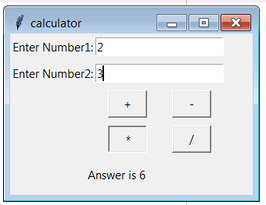

1. Make weight conversion GUI from kg to gram, pound and ounce using tkinter.

INPUT:

from tkinter import *

w=Tk()

var=IntVar()

w.geometry("300x200")

w.title("Calculator")

def show(op):

n1=int(e1.get())

n2=int(e2.get())

if(op=='+'):

ans=n1+n2

elif op=='-':

ans=n1-n2

elif op=='*':

ans=n1*n2

elif op=='/':

ans=n1//n2

else:

ans="choose proper operator"

ans='Answer is :',str(ans)

l3.config(text=ans)

l1=Label(w,text="Enter Number1:").grid(row=0,column=0)

l2=Label(w,text="Enter Number2:").grid(row=1,column=0)

e1=Entry(w)

e1.grid(row=0,column=1,columnspan=2)

e2=Entry(w)

e2.grid(row=1,column=1,columnspan=2)

b1=Button(w,text="+",width=5,command=lambda:show('+'))

b1.grid(row=3,column=1)

b2=Button(w,text="-",width=5,command=lambda:show('-'))

b2.grid(row=3,column=2)

b3=Button(w,text="*",width=5,command=lambda:show('*'))

b3.grid(row=4,column=1)

b4=Button(w,text="/",width=5,command=lambda:show('/'))

b4.grid(row=4,column=2)

l3=Label(w)

l3.grid(row=5,column=0,columnspan=4)

w.mainloop()

OUTPUT:

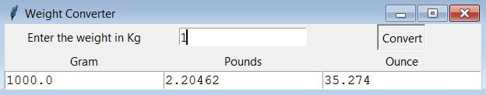

1. Write python GUI to make font menu.

INPUT:

from tkinter import *

top=Tk()

top.geometry("500x500")

font=StringVar()

def Font_change():

f=lfont.get(ACTIVE)

l4.config(font=(f,))

def font_style():

fsize=fontsize.get(ACTIVE)

fstyle=fontstyle.get(ACTIVE)

l4.config(font=('',fsize,fstyle))

def Font_size():

fsize=fontsize.get(ACTIVE)

l4.config(font=('',fsize,))

l1=Label(top,text="FontName")

l1.grid(row=0,column=0)

l2=Label(top,text="FontStyle")

l2.grid(row=0,column=1)

l3=Label(top,text="FontSize")

l3.grid(row=0,column=2)

lfont=Listbox(top)

lfont.insert(0,"Times")

lfont.insert(1,"Helvetica")

lfont.insert(2,"Arial")

lfont.insert(3,"Courier")

lfont.grid(row=1,column=0)

fontstyle=Listbox(top)

fontstyle.insert(0,'Regular')

fontstyle.insert(1,'italic')

fontstyle.insert(2,'bold')

fontstyle.insert(3,'bold italic')

fontstyle.grid(row=1,column=1)

fontsize=Listbox(top)

for i in range(150):

fontsize.insert(i,str(i+1))

fontsize.grid(row=1,column=2)

s=Scrollbar(top,orient="vertical")

s.grid(row=1,column=3)

fontsize.config(yscrollcommand=s.set)

s.config(command=fontsize.yview)

s.set(0,0)

l4=Label(top,text="Sample")

l4.grid(row=3,column=1)

b1=Button(top,text='Font',command=Font_change)

b1.grid(row=2,column=0)

b2=Button(top,text='Font',command=font_style)

b2.grid(row=2,column=1)

b3=Button(top,text='Font',command=Font_size)

b3.grid(row=2,column=2)

top.mainloop()

OUTPUT:

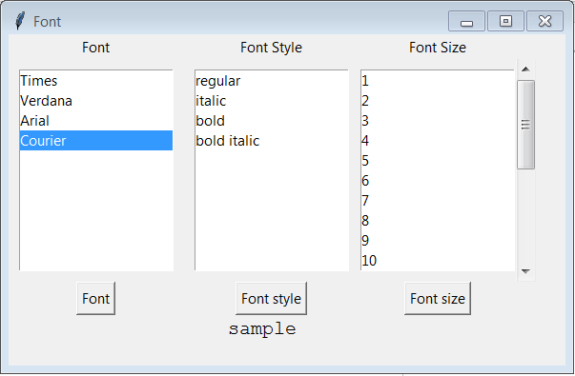

1. Create student registration page with enrollment, name, gender, address, branch name, mobile number and email address fields and store all data in data base.

INPUT:

